MDS Data Science Portfolio Part 1

MD Shuey

# Demonstration 1: Data Cleaning, Qualitative Analysis

### MediaMonitor: Collection methodology

In this dataset, headlines were compiled from a specific list of sources with the keyword “Brazil” since the prior business day of collection. Sports matters were omitted, with an emphasis on collecting news regarding the state of Brazil and its economy, society, and politics, categorized as *pillars*. From there, a *topic* if applicable further delved into relevant subcategories such as agriculture, technology, energy, etc.

This data was compiled between the beginning of the 2017 calendar year and the end of November. There were 222 days of headline collection during this time period, with 2045 total headlines. Of particular interest, a subjective qualitative variable *impact* was also given with each observation: Labelling a positive, negative, or neutral impact on a potential reader:

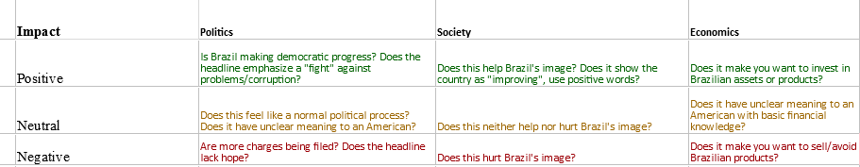

## New names:  
## * `` -> `..7`

#Data has been read in under the variable name "medmon"  
library(plyr)  
library(readxl)  
#tidying, establishing the correct variable types:  
medmon$Sources = as.factor(medmon$Sources)  
medmon$Pillar = as.factor(medmon$Pillar)  
medmon$Topic = as.factor(medmon$Topic)  
medmon$Impact = as.factor(medmon$Impact)  
medmon$Date = as.Date(medmon$Date, origin="1900-01-01")  
tail(medmon)

## # A tibble: 6 x 7  
## Title Sources Date Pillar Topic Impact ..7   
## <chr> <fct> <date> <fct> <fct> <fct> <chr>  
## 1 Goldman Sees Iron Ore~ Bloombe~ 2017-11-29 Econo~ <NA> Neutr~ <NA>   
## 2 Asian groups vie for ~ Reuters 2017-11-29 Econo~ Infrastru~ Posit~ <NA>   
## 3 - Brazil posts larger~ Reuters 2017-11-29 Econo~ <NA> Posit~ <NA>   
## 4 - Plan to help Brazil~ Reuters 2017-11-29 Econo~ <NA> Neutr~ <NA>   
## 5 - Brazil lower house ~ Reuters 2017-11-29 Polit~ Green Eco~ Posit~ <NA>   
## 6 - Brazil Senate appro~ Reuters 2017-11-29 Econo~ Politics Posit~ <NA>

#From here, the goal is to get a daily count for _impact_.   
library(plyr)  
counter = count(medmon$Date)  
  
mm_pos= subset(medmon, Impact == "Positive")  
mm_neg= subset(medmon, Impact == "Negative")  
c_pos = count(mm_pos$Date)  
c_neg = count(mm_neg$Date)  
counter = merge(counter, c_pos, by="x", all=TRUE)  
counter = merge(counter, c_neg, by="x", all=TRUE)  
colnames(counter)= c("Date","Total","Pos","Neg")  
  
head(counter)

## Date Total Pos Neg  
## 1 2017-01-05 14 3 7  
## 2 2017-01-06 11 1 7  
## 3 2017-01-09 9 NA 3  
## 4 2017-01-10 6 4 1  
## 5 2017-01-11 12 5 2  
## 6 2017-01-12 10 3 3

We have the initial structure now, but we need to retain counts of “0” for when we begin graphing. Then and only then we can subtract from our Total column to get the final Neutral column:

counter[is.na(counter)] = 0  
counter$Neu = counter$Total - counter$Pos - counter$Neg  
head(counter)

## Date Total Pos Neg Neu  
## 1 2017-01-05 14 3 7 4  
## 2 2017-01-06 11 1 7 3  
## 3 2017-01-09 9 0 3 6  
## 4 2017-01-10 6 4 1 1  
## 5 2017-01-11 12 5 2 5  
## 6 2017-01-12 10 3 3 4

## Visualization

I began without using ggplot. I manually added tick marks for each month; Although there may have been a way to code this, I called upon Occam’s razor and found the 11 observations where the month changed.

c_cols = c("Black", "Black", "Green", "Red", "Gray")  
plot.ts(counter$Total, ylim= c(0, 25), col="Green",   
 xaxt= "n", ylab="# of headlines", xlab= "Date (Jan-Nov)")  
 title(main= "2017 Articles by Impact")  
 axis(1, at=c(1, 18, 35, 58, 78, 100, 121, 140, 163, 183, 202), labels = c("Jan","Feb","Mar","Apr", "May", "Jun", "Jul","Aug","Sept","Oct", "Nov"))  
#We begin plotting by stacking each layer with an appropriate color label  
 polygon(x=c(1:222, 222:1), border = NA, y=c(counter$Total, rev(counter$Neg+counter$Neu)), col= "Green")  
 polygon(x=c(1:222, 222:1), border = NA, y=c((counter$Neg + counter$Neu), rev(counter$Neg)), col= "Grey")  
 polygon(x=c(1:222, 222:1), border = NA, y=c((counter$Neg), rep(0, times=222)), col= "Red")  
 legend("topright", c("Positive", "Negative", "Neutral"), fill = c("Green", "Red", "Gray"))

# 

Already we can see some interesting trends we will want to explore. From here we will switch to the more efficient code of ggplot. To make trends more visible to humans, we’re going to bin data by the week:

#Preparing the weekly sums  
counter$DateW=as.Date(cut.Date(counter$Date, breaks="week", start.on.monday = F))  
counterW=aggregate(cbind(counter$Total, counter$Pos, counter$Neg, counter$Neu)~DateW,data=counter,FUN = sum)  
colnames(counterW)=c("DateW", "Total", "Pos", "Neg", "Neu")  
#Plotting begins  
g1=ggplot(data=counterW, aes(x=DateW, y=Total)) +  
 geom_ribbon(aes(ymin=0, ymax=counterW$Neg),fill="red")+  
 geom_ribbon(aes(ymin=counterW$Neg, ymax=(counterW$Neg+counterW$Neu)), fill="gray") +  
 geom_ribbon(aes(ymin=(counterW$Total-counterW$Pos), ymax=counterW$Total), fill = "green") +  
 labs(title="2017 Articles by Impact", x="Date (Jan-Nov)", y="# of Articles")  
  
#Percentage of totals:  
  
counterW$posp=counterW$Pos/counterW$Total  
counterW$negp=counterW$Neg/counterW$Total  
counterW$neup=counterW$Neu/counterW$Total  
#Plotting continues  
g2=ggplot(data=counterW, aes(x=DateW, y=1)) +  
 geom_ribbon(aes(ymin=0, ymax=counterW$negp),fill="red")+  
 geom_ribbon(aes(ymin=counterW$negp, ymax=(counterW$neg+counterW$neup)), fill="gray", alpha=0.7) +  
 geom_ribbon(aes(ymin=(1-counterW$posp), ymax=1), fill = "green") +  
 labs(title="2017 Articles by Impact (Percentage)", x="Date (Jan-Nov)", y="% of Articles")  
g1

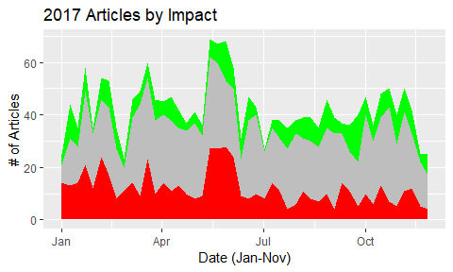

g2

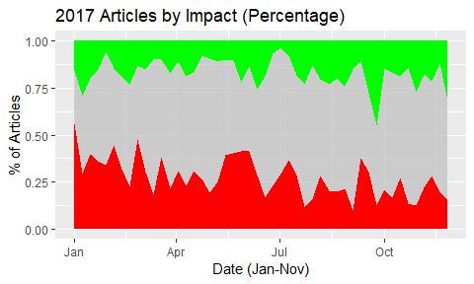

#Qualitative factor breakdown  
pill.imp = table(medmon$Pillar, by=medmon$Impact)  
pill.imp=as.data.frame(pill.imp)  
colnames(pill.imp)= c( "Pillar", "Impact", "Freq")  
ggplot(pill.imp, aes(Pillar, Freq, fill=Impact))+geom_bar(stat="identity", position = position_dodge()) +labs(title ="Article Pillars by Impact")

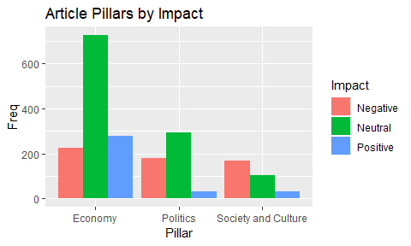

#A list of sources by categorized topic  
  
source.top = table(medmon$Sources, by=medmon$Topic)  
source.top = as.data.frame(source.top[])  
colnames(source.top) = c("Source", "Topic", "Freq")  
ggplot(source.top, aes(Source, Freq, fill=Topic))+geom_bar(stat="identity", position = position_dodge())+ coord_flip()+labs(title="Article Sources by Category")

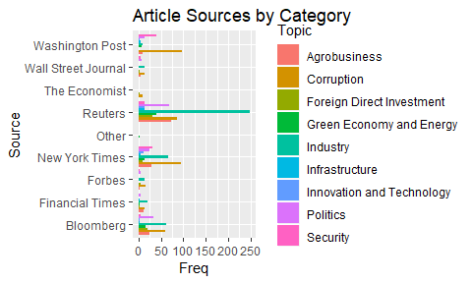 As we can see, there are some stark differences in the number of articles involving our subject country within each media source.

## Text Mining

Let’s say we were now interested in finding the most frequent words within headlines of the year.

library(tm)

## Loading required package: NLP

##   
## Attaching package: 'NLP'

## The following object is masked from 'package:ggplot2':  
##   
## annotate

library(SnowballC)  
library(data.table)

corp=medmon$Title  
corpstring=paste(corp,collapse = "", sep = " ")  
corpstring= VectorSource(corpstring)  
corp=VCorpus(corpstring )  
  
#Transformations to isolate the key root words of each headline  
corp=tm_map(corp, removePunctuation)  
corp=tm_map(corp, content_transformer(tolower))  
corp=tm_map(corp, removeWords, stopwords("english"))  
corp=tm_map(corp, stemDocument)  
matrix=DocumentTermMatrix(corp)  
#Determining most common word stems  
wordfreq = findMostFreqTerms(matrix, 100)  
wordfreq=wordfreq$`1`  
wordfreq=as.data.frame(wordfreq)  
wordfreq=setDT(wordfreq, keep.rownames=T)  
head(wordfreq, 25)

## rn wordfreq  
## 1: brazil 456  
## 2: say 152  
## 3: temer 122  
## 4: presid 76  
## 5: new 73  
## 6: brazilian 71  
## 7: court 66  
## 8: pension 65  
## 9: corrupt 63  
## 10: reform 63  
## 11: bank 62  
## 12: see 62  
## 13: probe 53  
## 14: petrobra 52  
## 15: cut 51  
## 16: polic 51  
## 17: rate 51  
## 18: billion 50  
## 19: may 49  
## 20: sale 48  
## 21: graft 47  
## 22: brazil 46  
## 23: polit 46  
## 24: rio 44  
## 25: central 43  
## rn wordfreq

From here we can filter keywords and find the key terms readers have seen with their news over the year. These are simple examples of the insight that can be gained from such data; Much more robust collection methods can lead to an even fuller picture of a country’s portrayal in the media.